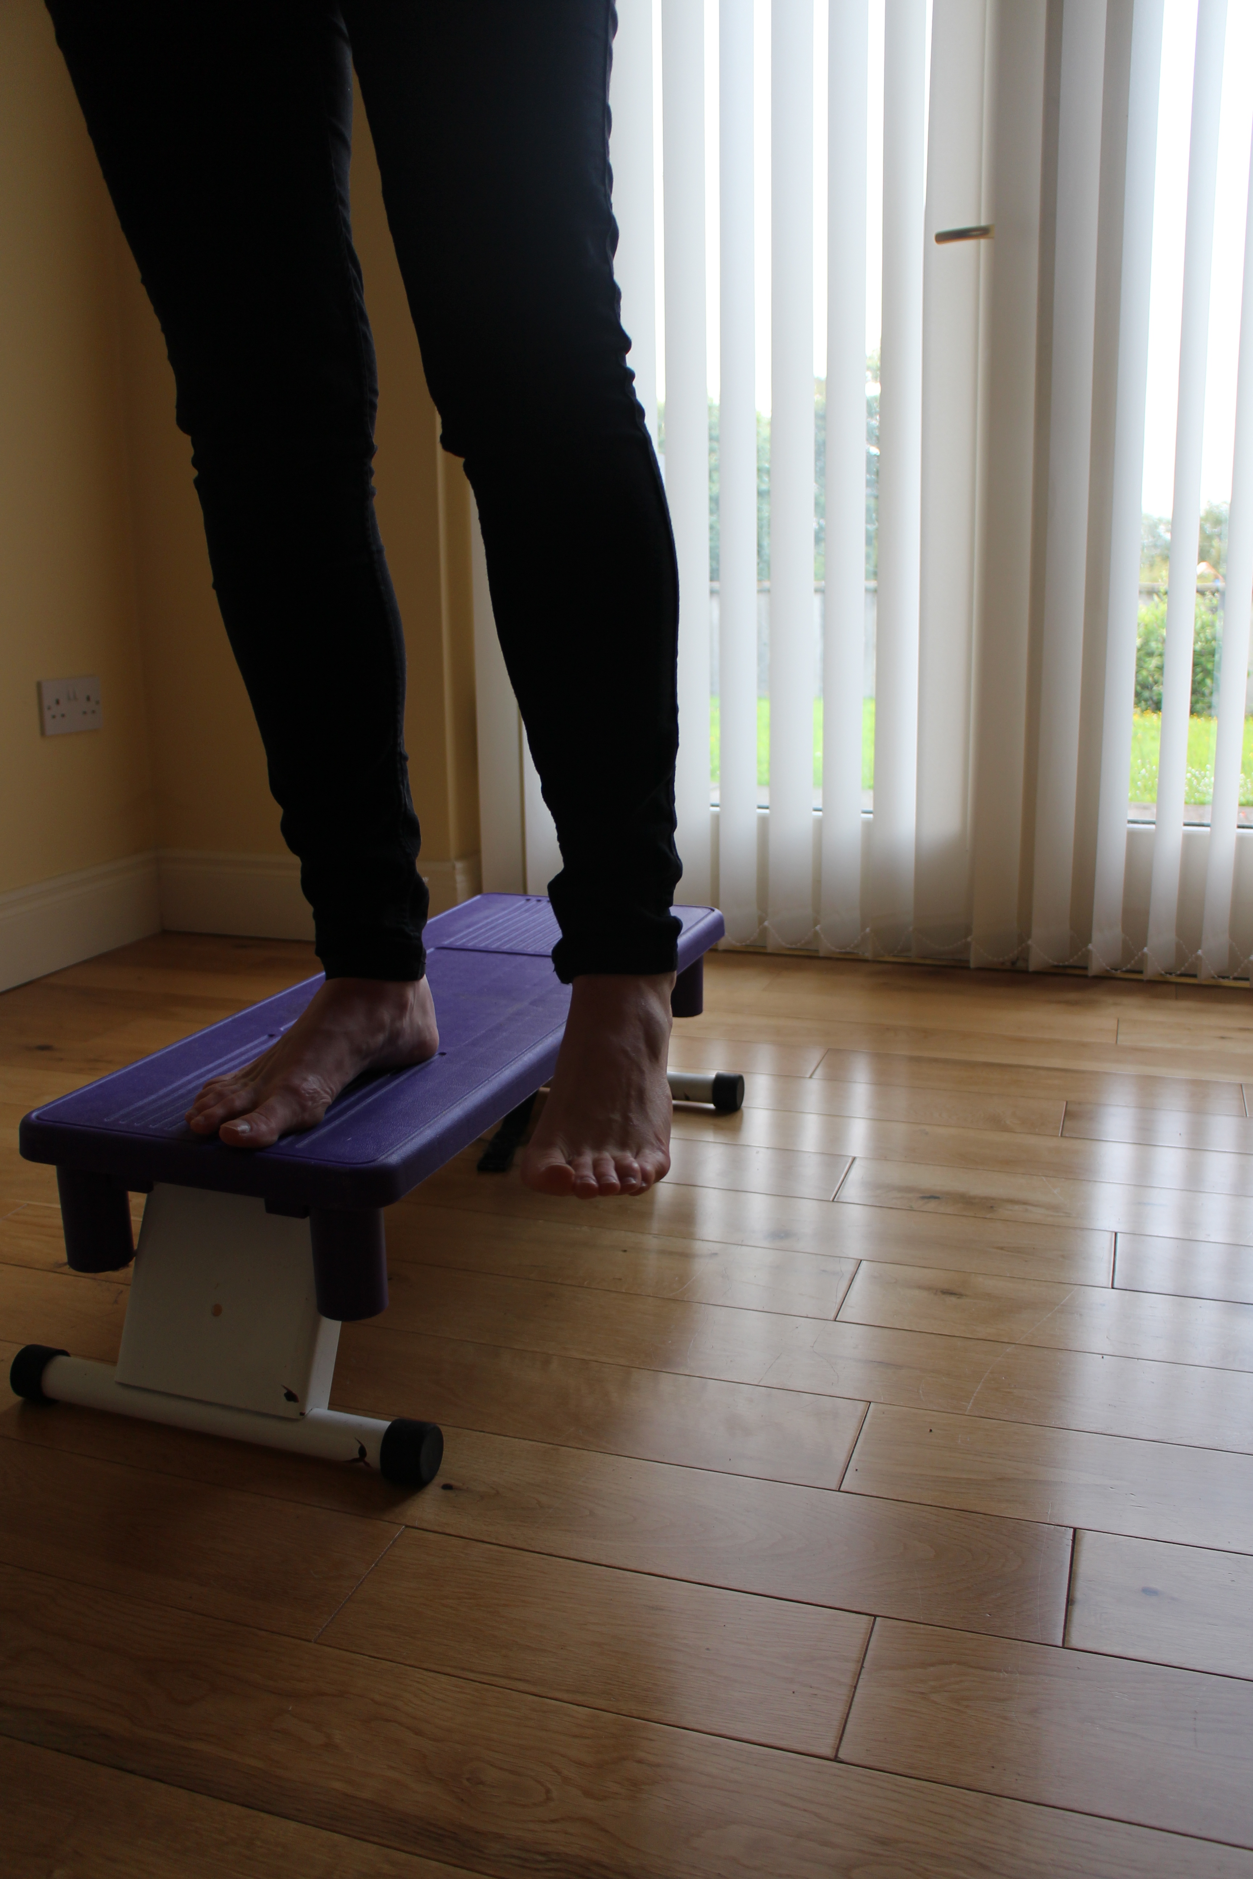 | 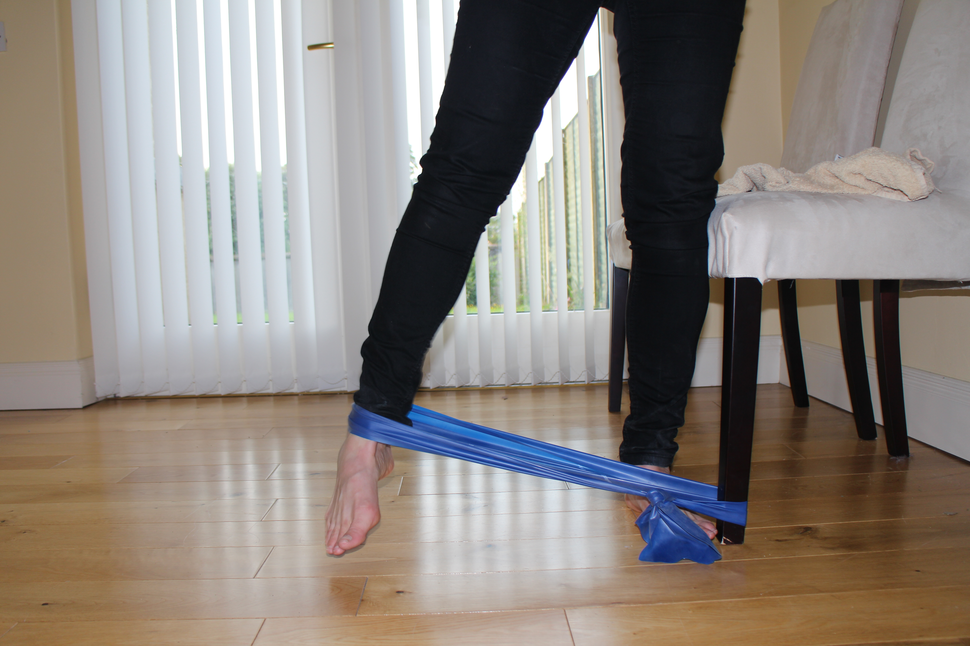
Gluteus Medius Leg Drop keep pelvis stable engage abdominals | Hip Abduction with resistance band.

 | 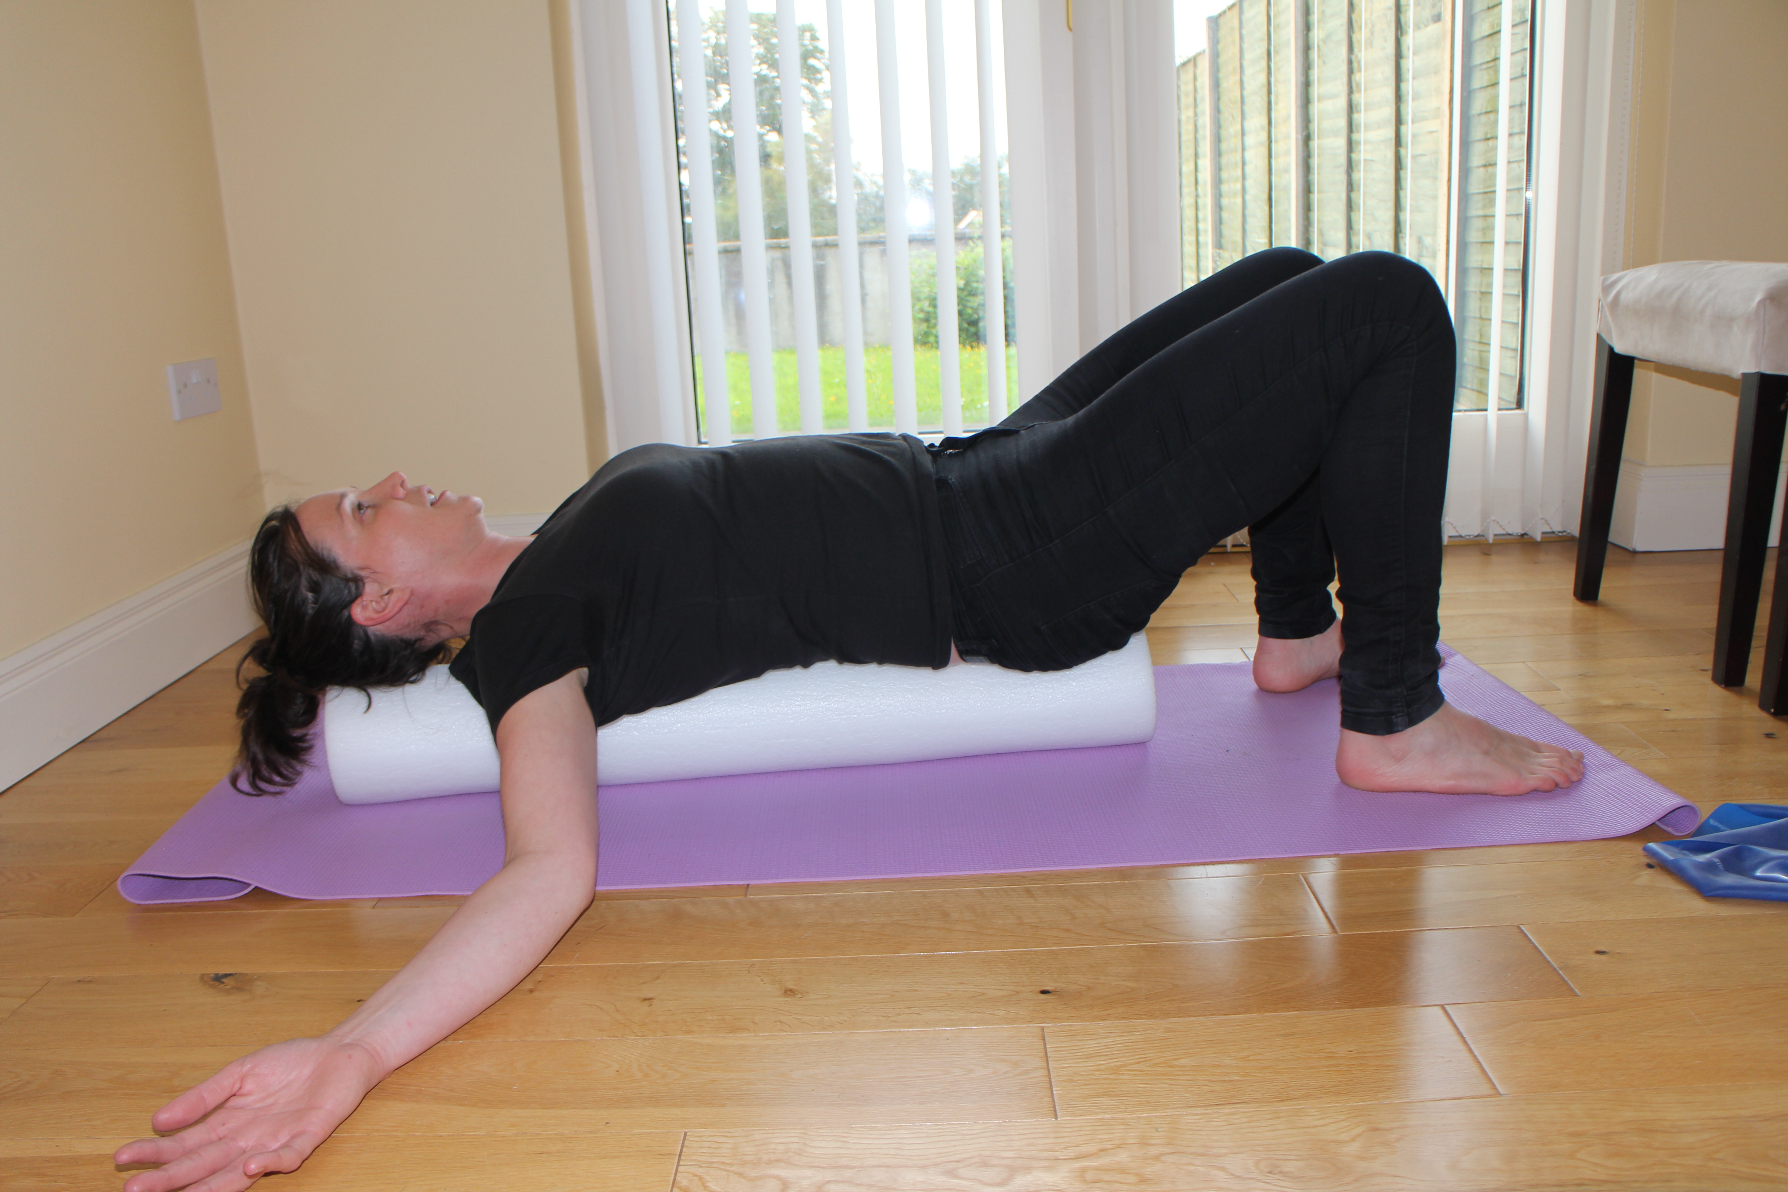
Foam Rolling spine | Foam Roller Chest opener.

